**A Dynamical Dual Systems Model of Human Collaboration**

Neeraj Chatlani, Sunny Kotwal, Jeralyn Parchman, Megan Wiedbusch

University of Central Florida

IDS 6267: Understanding Humans in Modeling and Simulation

Dr. Patricia Bockelman

March 25, 2021

**A Dynamical Dual Systems Model of Human Collaboration**

Humans interact and connect with the world and other cognitive agents in numerous ways. Consequently, there are just as many ways to measure and analyze this interaction, such as through the perspective of virtual worlds (e.g., video games). One such analytical direction is a dynamical systems approach, such as connectionism (Smolensky, 1988), or more contemporary brain-inspired research using nonlinear dynamical approaches (Favela, 2020; Bucker & Garson, 2019; van Gelder, 1998). Generally, in attempts to capture the nuance and complexity of cognition, this approach makes the broad argument that human agents are not systems that contain cognitive properties, but rather are objects that instantiate (i.e., create or represent a solidified example through abstraction) multiple systems (van Gelder, 1998). Ultimately, it is the amalgamation of multiple instantiations that account for cognition (van Gelder, 1998). However, currently there does not exist a dynamical systems model of cognition that can be used to represent human collaboration while accounting for cognition, metacognition, co-imagination, and interpersonal relationships with other cognitive agents.

Below, we describe a dual-system framework built upon a convergent of previously proposed and tested models addressing these phenomena and relationships, interpreted through the lens of shared information through various communication medium filters. Our model pointedly accounts for the adaptability of human interaction and collaboration accommodating perpetually shifting contexts, and environmental conditions and affordances. We show that the nature of an interpersonal relationship depends on the shared metacognition derived from a history of communication, the nature of the medium through which that communication is facilitated, and each agent’s internal perception and dynamic expansion of the metacognitive relationship. Additionally, we depict the imperfect nature of information and the reciprocal updating of a working model of the world (e.g., one’s imagination; Bulley et al, 2019; Pelaprat and Cole, 2011).

At its core, this model proposes a dual-system to model human collaboration, developed from Shea, Boldt, Bang, Yeung, Heyes, and Frith (2014)’s supra-personal theoretical framework. System 1 consists of a single cognitive agent’s cognition, metacognition, and working memory, while System 2 comprises the interdependent representation of cognitive agents’ shared and independent cognition, metacognition, and the resulting interpersonal relationship derived from cycles of interpersonal metacognition, which simply represents how each agent views each other in a socio-communicative context. We have expanded upon the original model by introducing and integrating components from (1) McCubbin & McCubbin’s (1988) conceptual model of family adjustment and adaption to stress, (2) Wisniewski’s (2015) theoretical model of adolescent risk reliance, (3) Anderson, Matessa, & Lebiere’s (1997) ACT-R Model of Cognition, (4) Jia and colleagues’ (2020) Perceptual Interaction model, (5) Loschky and colleagues’ (2019) Scene Perception & Event Comprehension Theory (SPECT), (6) Tan & Visch’s (2018) Cycles of Co-Imagination model, and (7) Bratman, Israel, & Pollacks’(1988) Belief-Desire-Intention (BDI) theory. Below, we describe System 1 and its components of a single-cognitive agent system before diving into System 2 (a supra-personal cognitive and metacognitive system composed of multiple cognitive agents). We ground this discussion with an example of technology-mediated communication between two individuals.

This model was developed by merging several models of human-world interactions models previously designed by the authors. The base of the new integrated collaboration model was pulled from Megan’s dual-system approach. We then integrated the way interpersonal relationships are augmented and stored in memory as understood by Neeraj’s model. This influences the way that the communication of System 2 operates and is fed back into the system. Pulling from Jeralyn’s model, we added the recursive match and expansion process of co-imagination, or working memory, of a current perceived model. While originally this was conceived in the context of media (e.g., film, tv, movies, etc), we recontextualized it around the communication and interpersonal relationship factors of technologically-mediated communication from Neeraj’s model. In discussion to incorporate the co-imagination process, we spent some time considering the differences between the metacognitive process and co-imagination. While co-imagination was more closely related to the processing of visual stimuli, out base model represented a significantly different process of interpersonal metacognition used to represent a relationship between individuals. This led to us abstracting the co-imagination process as a match-and-expand function based on our new stimulus of interpersonal communication. Finally, we abstracted the model and more clearly defined the type and quality of information being passed between modules as described in Sunny’s original model. In his model, the communication was contextualized by the transfer medium, which had its own set of social nuances and possible restrictions compared to in-person communication. For our purposes, we adapted this interpretation to exist as a socio-contextual filter for the metacognitive process, by which each individual considered the social nuances of each other’s communication.

**System 1 - Single Cognitive Agent**

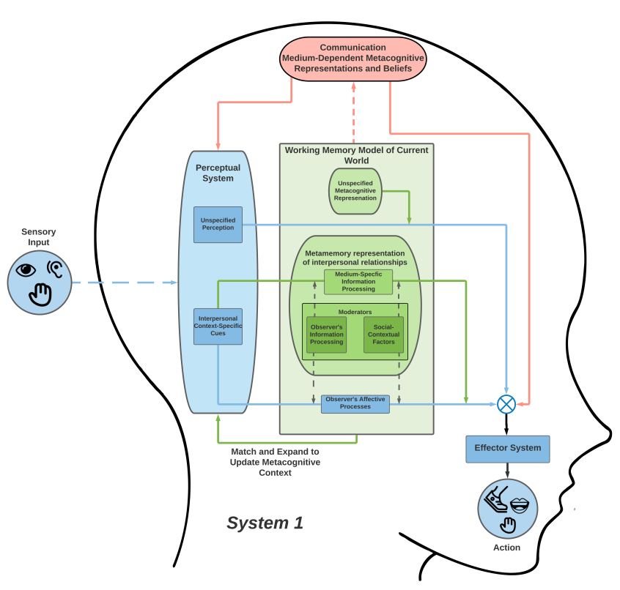

**Figure 1:** System 1 model of a single agent’s cognition and metacognition in context of interpersonal relationships

***Perceptual System***

System 1[1] (see Figure 1), on a high-level granular view, abstracts a perception-action cycle that begins with sensory input (e.g., sound of another person talking, etc.) from the environment. Sensory input is represented with a broken line to represent the potential for an imperfect input. A 24 frames per second (fps) video would be an example of imperfect input where most eyes can detect subtle changes from 400 to over 1000 fps (Chase, 1974). We acknowledge that there are many components of the perceptual system (left blue box) that this information is passed to, however, our model highlights only one specifically -- interpersonal context-specific cues (e.g.,facial expressions captured visually, dialogue with a partner, text messages, etc.). Eye-tracking could help provide temporal-spatial data as evidence of attention while auditory perception of sudden or loud noises could be linked to changes in heart rate or skin conductance. Qualitatively, we can capture individual sentiment concerning the perception of the interpersonal relationship through interviewing these individuals to understand the history of the communicative relationship, along with their technical and socio-contextual knowledge of the communication medium’s capabilities (i.e. the social nuances that guide how they, as an individual, utilize the medium in communicating with the other individual based on the nature of their relationship). Taken together, this knowledge amounts to the individual’s perceptions of how they typically communicate with their counterpart and interpret any subsequent replies.

Filtered from these inferential processes (modeled with the dotted pink arrow moving upwards), metacognitive representation and beliefs, whose availability are dependent on the means in which they can be communicated (i.e., are both conscious and can be expressed), are further integrated with other sources of similar metacognition (i.e. arising from unspecified metacognitive representations, plans and goals, and from the working model of the current environment). Ultimately, this integrated form of metacognition is dependent on the technical and socio-contextual knowledge of how to communicate via a given medium, and the history of the relationship to the other party, given the past cycles of communication. This filtering process was designed based on decision filtering mechanisms described in Bratman et al.’s (1988) BDI theory. Specifically, a compatibility filter determines if the metacognitive information is (1) conscious and therefore is (2) able to be broadcasted, constrained by various communication mediums (e.g., verbally, through text, icons, etc.).

***Interpersonal Cognition as Representation of Relationships***

Repeated communications of any form between two individuals constitutes the basis of an interpersonal relationship. This cognitive process of sending and receiving communication in any medium causes both individuals to eventually develop and understand the socio-contextual nuances of how each communicates with the other through that specific medium (e.g. verbal speech, texts, voice messages, etc.). In other words, both individuals are developing their communicative relationship, which informs how future communication is undertaken and processed. Within our System 1, this functions as the moderating processes within the working memory model. Each cognitive cycle of processing received communication results in an update of the memory module via the match and expand process, which in turn affects how the moderating processes inform the individual’s interpretation of their next communication. This represents an adaptation in the functional metamemory of the relationship.

The concept of adaptations based on dynamically interpreted situations is taken from McCubbin and McCubbin’s model of Family Resilience (1988), where this adaptation is dependent on the situational appraisal of family members’ capacity to address a specific problem event. Given the family’s interpersonal problem solving skills, available resources, and social support, an adaptation is made to support the contextual resolution of the problem, which is adhered to by all members of the family going forward. Within the context of interpersonal relationships, every cycle of communication causes an adaptation in the individual’s metacognitive representations of how the other individual communicates. This adaptation is dependent on the nature of the previous communications, the socio-contextual nuances and/or restrictions of the communication medium, and the results of the match and expand process, which updates how the individual contextually interprets future communication. It is especially important to consider the impact of the communication medium on the individual’s socio-contextual interpretation of communication. A medium like in-person, verbal speech contains a specific set of social nuances and non-cognitive cues for the individual to interpret, whereas an online medium like texting contains vastly different social contexts and forms on non-direct communication which required more interpretation from the receiving individual (eg. emojis, ellipses after a sentence, etc.).

***Working Memory Model and the Match and Expand Process***

During technology-mediated communication, the working memory model and the match and expand process play an active role in informing and updating the individual’s interpretation of the information derived from the perceptual system. In general, the working memory serves as the space in which a mental model of a situation is created and built upon. During this cognitive process, the mental model proceeds through multiple matching and expansion cycles, a concept derived from the Cycles of Co-Imagination process described by Tan and Visch (2018). Originally applied to film-viewing, this process depicts how filmmakers “manipulate the viewer’s expectations regarding where the construction of the fictional world is heading” by providing them with prompts through the film scenes, which viewers then expand on by further imagining the fictional world (Tan & Visch, 2018). When applied to technology-mediated communication, this process allows an individual to interpret emojis, expressions, and symbols as full sentences or situations by identifying (matching) the representation of the conversation and then deriving context-based meanings (expanding) from them. As each prompt is matched and expanded, the individual becomes more emotionally invested in their personal interpretation of the information being communicated. Furthering the personalized nature of this process, the number of matching and expansion cycles is entirely dependent on the individual, as each person responds differently based on their personal experiences and disposition. For this reason, an individual’s emotional investment in an imagined event can heavily influence their reaction, especially in cases where one individual has a different mental image of the situation being communicated than another.

***Effector Systems and Action***

Executive function control, or the integration of cognitive processes being run in parallel within System 1, raises questions regarding what actually determines action and behavior. Due to our level of abstraction, we have refrained from explicitly defining how contradictory actions are resolved but point to this area for future expansion through integration from other well-researched and established methods such as contention scheduling and supervisory attentional systems (Shallice & Burgess, 1996).

**System 2 - Multi-Cognitive Agent**

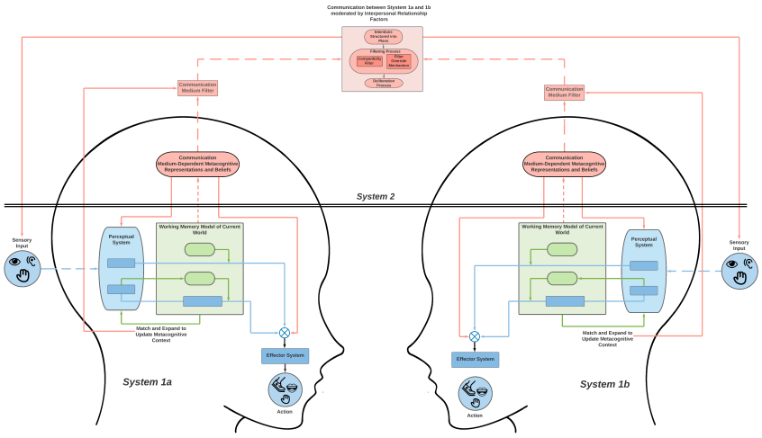

**Figure 2:** System 2 model of multi-agents’ cognition, metacognition, and interpersonal relationships

System 2 considers supra-personal cognitive and metacognitive processes as multiple Systems 1s coupled within the system to model collaboration. These supra-personal processes are required for the sharing of potentially isolated metacognitive information across System 1s that may only be accessible to one of the cognitive agents (e.g., the on-screen information on their personal device; Shea et al., 2014). We expanded our original models to include representations of how collaborative communication occurs using technology. First, information is constrained by not only contextual factors but also the dynamics and nuances of the relationship between agents and the medium with which they are interacting (described above). Additionally, we implemented a node called the communication medium filter, which represents the various potential ways the two agents may be interacting such as in person, via text, or by Zoom. The methods used to interact between the agents may significantly affect how they connect. This goes hand in hand with the idea of imperfect input. With interactions only by text, figuring out the tone (e.g. sarcastic quips) might be quite difficult while if it was in person more information is being received from inflection of voice to body language.

This imperfect information (i.e., colored by various metacognitive judgements and beliefs about context) is then communicated between agents working on a common goal or task. This collaboration requires deliberation, a process we modeled using Bratman et al. (1998)’s BDI architecture. This begins with the intentions of the agents into plans either formally (e.g., “first I will…, then you will…”) or informally (e.g. “I hope we work well together!”). These ideas, plans, and goals are then further filtered so that only relevant or medium-compatible information is shared. During and following the deliberation process, information and utility are set back into each System 1’s effector systems to begin action of each agent. Simultaneous with these processes, matching and expanding takes place continuously, serving two major purposes. The first is to update the working memory model, which affects an individual’s metacognitive representations and beliefs and is eventually passed through the communication medium filter and to the interpersonal deliberation process. The match and expand process also directly feeds into the communication medium filter, as the emotional investment created by repeated expansions can influence the manner in which an individual chooses to engage with the communication medium. During the interpersonal relationship, any additional sensory input, such as that which results from the deliberation process depicted in System 2, is eventually used to update the working memory model of the current relationship in each System 1.

For empirical purposes, the quality of collaboration could be coded and quantified using reliable and valid coding-schemes to reflect the depth and nature of the relationship between individuals. This could then be used to develop rich time-series data as representations of the working models each System 1 is housing.

**Conclusion**

Our theoretical model makes multiple assumptions that should be further examined, such as whether metacognition needs a model representation (i.e., imagination) of perception or our cognition. Additionally, we wonder how multi-level communication works within this model’s filtering process. For example, if we have both a texting and face-to-face based relationship, is the filtering and updating of the metacognitive interpersonal details of our relationship still kept separate based solely on the technology or do we develop a hybrid filter based on the second cognitive agent? Our current model also allows for much richer expansion to include other types of cognitive system processes (e.g., motivation, action decision making components, etc.).

This dual-systems model of cognition, metacognition, and interpersonal relationships provides the foundation to test empirical questions and hypotheses. For example, why are some metacognitive judgments verbalized (e.g., “this game is hard!”) while others are left internal to shape our mental models but still influence our behaviors (e.g., being more competitive when collaborating with an adversary versus friendly peer). Future development of our model should expand upon these processes while addressing theoretical assumptions by providing empirical evidence with which to test the model’s validity of human behavior. We interact and collaborate with each other daily, and ultimately the study of human cognition should consider these collaboration systems holistically, even when studying more granular (relative to cultural or social phenomenon) processes and mechanisms.

**References**

Anderson, J. R.,Matessa, M., & Lebiere, C. (1997). ACT-R: A theory of higher level cognition and its relation to visual attention. *Human-Computer Interaction, 12*(4), 439-462.

Bratman, M. E., Israel, D. J., & Pollack, M. E. (1988). Plans and resource‐bounded practical reasoning. *Computational intelligence, 4*(3), 349-355.

Bucker, C., & Garson, J. (2019). Connectionism. In E. N. Zalta (Ed.), *The Stanford encyclopedia of philosophy (fall 2019th ed.).* Stanford, CA: Stanford University Retrieved from https://plato.stanford.edu/archives/fall2019/entries/connectionism/

Bulley, A., Redshaw, J., & Suddendorf, T. (2020). 26. The future-directed functions of the imagination: From prediction to metaforesight. In A. Abraham (Eds.), *The Cambridge handbook of the imagination*, 425-444.

Chase, R. (1974). The initiation and conduction of action potentials in the optic nerve of Tritonia. *Journal of Experimental Biology, 60*(3), 721-734.

Favela, L. H. (2020). Dynamical systems theory in cognitive science and neuroscience. *Philosophy Compass, 15*(8), e12695.

Jia, Y., Liu, Z., Wang, C., & Xu, L. (2020). Research on the perceptual interaction model of virtual reality films. *Virtual, Augmented and Mixed Reality. Industrial and Everyday Life Applications*, 236–248. https://doi.org/10.1007/978-3-030-49698-2_16

Loschky, L. C., Larson, A. M., Smith, T. J., & Magliano, J. P. (2020). The scene perception & event comprehension theory (SPECT) applied to visual narratives. *Topics in Cognitive Science*, *12*(1), 311–351. https://doi.org/10.1111/tops.12455

McCubbin, H. I., & McCubbin, M. A. (1988). Typologies of resilient families: emerging roles of social class and ethnicity. *Family Relations, 37*(3), 247–254. https://doi.org/10.2307/584557

Pelaprat, E., & Cole, M. (2011). “Minding the gap”: Imagination, creativity and human cognition. *Integrative Psychological and Behavioral Science*, *45*(4), 397–418.

Shallice, T., & Burgess, P. (1991). Higher-order cognitive impairments and frontal lobe lesions in man*.* In H. S. Levin, H. M. Eisenberg, & A. L. Benton (Eds.), *Frontal lobe function and dysfunction* (p. 125–138). Oxford University Press.

Shea, N., Boldt, A., Bang, D., Yeung, N., Heyes, C., & Frith, C. D. (2014). Supra-personal cognitive control and metacognition. *Trends in cognitive sciences, 18*(4), 186-193.

Smolensky, P. (1988). On the proper treatment of connectionism. *Behavioral and brain sciences, 11*(1), 1-23.

Tan, E. S.-H., & Visch, V. (2018). Co-Imagination of fictional worlds in film viewing. *Review of General Psychology*, *22*(2), 230–244. https://doi.org/10.1037/gpr0000153

Van Gelder, T. (1998). The dynamical hypothesis in cognitive science. *Behavioral and brain sciences, 21*(5), 615-628.

Wisniewski, P., Jia, H., Wang, N., Zheng, S., Xu, H., Rosson, M. B., & Carroll, J. M. (2015). Resilience mitigates the negative effects of adolescent internet addiction and online risk exposure. *Proceedings of the 33rd Annual ACM Conference on Human Factors in Computing Systems - CHI ’15*, 4029–4038. https://doi.org/10.1145/2702123.2702240

1. It is important to note that while not expanded upon currently, this model argues from both an extended (i.e., the environment with which the sensory originates) and embodied (i.e., the body with which senses the sensations) cognitive perspective. As such these components are considered part of the system but do require future expansion and explanation outside the scope of the current model.